**The Silent Threat: A Comprehensive Study on Hypertension**

**Abstract**

Hypertension, often referred to as the "silent killer," remains a leading global health concern, affecting over 1.3 billion individuals worldwide and significantly contributing to cardiovascular morbidity and mortality. This study explores advanced machine learning (ML) and deep learning (DL) methodologies to enhance the early detection and prediction of hypertension. Leveraging a multi-modal dataset comprising ballistocardiography (BCG), photoplethysmography (PPG), and ultrasound (US) signals, we employ rigorous preprocessing techniques, including outlier handling and class balancing via SMOTE and ADASYN. Feature selection methods such as ANOVA, Chi-Square, PCA, and RFE refine critical predictors, while models like XGBoost, Random Forest, and Support Vector Machines demonstrate robust performance. Hyperparameter optimization ensures peak efficacy, with XGBoost achieving the highest accuracy of 89.98%. The study highlights the importance of model interpretability, emphasizing its clinical relevance through techniques like SHAP and LIME. By addressing challenges in accessibility, scalability, and real-world applicability, this research establishes a foundation for integrating AI-driven hypertension detection systems into clinical practice, particularly in resource-constrained settings. These findings underscore the transformative potential of machine learning in mitigating the global burden of hypertension.

**Introduction**

**Background and Context :**

Hypertension, commonly referred to as high blood pressure, remains one of the leading risk factors for cardiovascular diseases (CVD) and a major public health challenge worldwide. According to the Global Burden of Diseases study, hypertension is responsible for over 10 million deaths globally, with many individuals undiagnosed or inadequately treated, particularly in low- and middle-income regions. The prevalence of hypertension is escalating, with more than 1.3 billion individuals affected worldwide, further exacerbating the global burden of cardiovascular morbidity and mortality. Given its asymptomatic nature in the early stages, hypertension often goes unnoticed, leading to delayed diagnosis and intervention, which underscores the importance of developing effective and accessible methods for early detection.

**Problem Statement :**

The rapid advancement of machine learning (ML) and deep learning (DL) techniques has significantly enhanced the accuracy and efficiency of hypertension detection using diverse signal modalities, such as ballistocardiograms (BCG), photoplethysmography (PPG), and ultrasound (US) images. While various studies have demonstrated remarkable accuracy, such as 97.78% with the OddEven28 model using BCG signals (Agarwal et al.[1]) and 98.48% with Gradient Boosting and LSTM models (Choi et al.[2]), several critical challenges persist.

These include a lack of model interpretability (Smith et al.[3]; Nguyen et al.[7]), limited validation on diverse datasets (Zhang et al.[5]; Brown et al.[4]), and insufficient integration of advanced models into clinical practice (Gupta et al.[6]). Additionally, studies often highlight the need for improving the accessibility of hypertension detection in resource-limited settings (Li et al.[8]; Hasan et al.[18]) and addressing disparities in hypertension management due to demographic, socioeconomic, and regional variations (Leung et al.[17]; Sahatqija et al.[13]).

Despite advancements in signal processing and feature extraction, many approaches lack real-world applicability, especially in addressing patient-specific factors and ensuring explainability for healthcare providers (Smith et al.[3]; Nguyen et al.[7]). Moreover, hypertension's global burden remains a pressing concern, with challenges in public awareness and early diagnosis contributing to its continued prevalence and associated health risks (Charchar et al.[15]; Pinto et al.[14]).

This study aims to address these limitations by leveraging balanced and diverse datasets, incorporating interpretable ML models, and exploring feature selection and optimization techniques to enhance the accuracy and clinical relevance of hypertension detection systems.

**Objectives of the Study:**

The primary objective of this study is to explore novel machine learning and deep learning approaches for the automated detection and prediction of hypertension, utilizing a multi-modal dataset of BCG, PPG, and ultrasound signals. By employing advanced feature extraction techniques and ensemble learning methods, we aim to improve the classification accuracy of hypertension detection while ensuring that our models remain interpretable and reliable for clinical applications. The study will also evaluate the effectiveness of these models in real-world scenarios, aiming to bridge the gap between theoretical performance and practical applicability.

**Methodology Overview :**

In this study, data on hypertension was collected using a combination of real-life measurements and a Google Form questionnaire. The dataset underwent preprocessing to handle missing values and outliers, followed by balancing using techniques like SMOTE, ADASYN, and SMOTEEN to address class imbalances. Feature selection was conducted using ANOVA, Chi-Square Test, PCA, and RFE, while various machine learning models (RF, DT, SVM, LR, KNN, SVC) were applied to predict hypertension. Hyperparameter tuning and cross-validation ensured optimal performance, and evaluation metrics like accuracy and ROC-AUC were used to analyze the results.

**Significance and Contributions:**

The significance of this research lies in its potential to enhance the early detection and prediction of hypertension, thus providing timely interventions that could mitigate the risk of severe cardiovascular events. By improving both model performance and interpretability, this study contributes to the growing field of AI-assisted healthcare, where data-driven insights can empower clinicians and improve patient outcomes. Furthermore, the proposed models could pave the way for more accessible, non-invasive, and accurate hypertension detection tools, particularly in resource-limited settings. Through this work, we hope to set a new benchmark for automated hypertension monitoring, offering a practical and scalable solution to a pressing global health issue.

**Related Works**1. Agarwal et al.[1] The OddEven28 model achieved a classification accuracy of 97.78% for detecting hypertension using BCG signals. This model employs the k-nearest neighbors (kNN) algorithm, which classifies data points based on their proximity to labeled training samples. The OddEven28 model utilizes a unique feature extraction process called the Odd-Even Pattern (OEP), generating specific feature vectors by analyzing alternating odd and even indices from the BCG signals. To enhance the feature set, singular pooling is applied, combining singular value decomposition with statistical feature extraction to capture detailed signal characteristics. This innovative approach resulted in a robust 28-feature vector set, which was validated through iterative majority voting, further increasing classification reliability and accuracy.

2. Choi et al.[2] Hypertension prediction emphasize the efficacy of machine learning (ML) and deep learning (DL) techniques. Models like Gradient Boosting (GB) and Long Short-Term Memory (LSTM) have shown remarkable accuracy, with GB-based feature generation combined with LSTM achieving an impressive accuracy of 98.48%. Other ML models, such as Random Forest and XGBoost, also performed well, with accuracies between 95% and 97%. In contrast, Logistic Regression yielded a lower accuracy of 89.39%. These findings suggest that advanced predictive tools can significantly aid clinicians in early hypertension detection, offering a pathway for more effective healthcare interventions.

3. Smith et al.[3] Hypertension detection through photoplethysmography (PPG) signals has gained traction due to its non-invasive nature and potential for early diagnosis. Previous models have leveraged machine learning algorithms such as support vector machines and random forests, achieving accuracies ranging from 85% to 95%. However, a significant limitation of these models is their lack of interpretability, which poses challenges for clinical adoption. Recent advances have incorporated explainable AI techniques; for instance, the use of Gradient-weighted Class Activation Mapping (Grad-CAM) has shown promise in elucidating model predictions, enhancing clinician trust in the outcomes. Our proposed

ExHyptNet model stands out by achieving a 100% detection rate for normal and multi-stage hypertension across multiple validation techniques on two public datasets, PPG-BP and MIMIC-II. By employing an ensemble approach with EfficientNetB3 for feature extraction and classifiers like XG-Boost and Extremely Randomized Trees, ExHyptNet addresses both performance and interpretability, setting a new benchmark for automated hypertension detection systems.

4. Brown et al.[4] The Global Burden of Diseases, Injuries, and Risk Factors Study (GBD) 2019 provides a comprehensive assessment of risk factors affecting global health. It evaluates 560 risk–outcome pairs, improving upon previous iterations by incorporating new data sources and methodologies, including spatiotemporal Gaussian process regression for exposure estimation. The study employed a systematic approach to quantify attributable mortality and disability, calculating disability-adjusted life-years (DALYs) through advanced statistical techniques. Notably, it achieved a robust estimation of risk factors’ impact, highlighting high systolic blood pressure as a leading cause of mortality, accounting for 10.8 million deaths globally. The GBD methodology also emphasizes interpretability and transparency in data synthesis, essential for informing public health policies. With substantial accuracy improvements and innovative risk assessment techniques, GBD 2019 enhances understanding of global health trends and informs targeted interventions.

5. Zhang et al.[5] The proposed work on automating hypertension (HTN) detection using ultrasound (US) images presents a significant advancement in cardiac assessment. Leveraging a Directional-Guided Motion Sensitive (DGMS) descriptor, the study achieved an impressive classification accuracy of 98% with a K-Nearest Neighbor (kNN) algorithm, showcasing superior performance compared to existing methods. Previous studies have demonstrated varying accuracy levels in HTN detection using imaging techniques, often falling between 85% and 95%. This research builds on the foundation of machine learning in medical imaging by emphasizing the potential of US to reveal predictive signals, even when standard measures appear normal. By developing a structured pipeline involving preprocessing, feature extraction, ranking, and classification, the study lays the groundwork for future AI-assisted diagnostic tools, which could significantly enhance early detection of HTN in clinical settings. Further validation on diverse datasets will be crucial for establishing the model's reliability and applicability in real-world scenarios.

6. Gupta et al.[6] Systemic arterial hypertension remains the leading modifiable risk factor for morbidity and mortality globally, significantly increasing the risk of cardiovascular disease (CVD). Despite the availability of effective treatments, awareness and management of hypertension remain inadequate, with fewer than half of affected individuals being properly treated. Recent studies emphasize the importance of accurate blood pressure (BP) measurement and comprehensive patient evaluation, which includes assessing atherosclerotic CVD risk and identifying secondary causes of hypertension. Lifestyle interventions and pharmacological therapies, particularly first-line antihypertensive agents such as ACE inhibitors and calcium-channel blockers, have demonstrated substantial efficacy in lowering BP and preventing CVD outcomes. Machine learning algorithms are increasingly being explored for their potential in predicting hypertension and assessing treatment efficacy, with recent models achieving accuracies exceeding 90% in identifying at-risk populations. This research underscores the need for improved awareness, early detection, and effective management strategies to mitigate the global burden of hypertension and its associated health risks.

7. Nguyen et al.[7]. The tension between model accuracy and interpretability has led to the development of various methods for understanding complex models, particularly in the context of ensemble and deep learning approaches. SHAP (SHapley Additive exPlanations) emerges as a unified framework that assigns importance values to features for individual predictions, leveraging concepts from cooperative game theory. Its innovative class of additive feature importance measures distinguishes SHAP from other methods, ensuring a unique solution that adheres to desirable theoretical properties. This framework unifies six existing interpretability methods, addressing limitations found in recent approaches. The authors also introduce new methods inspired by this unification, demonstrating improved computational efficiency and alignment with human intuition, making SHAP a significant advancement in the field of model interpretability.

8. Li et al.[8] Pulmonary hypertension (PH) is a complex condition with significant health implications, characterized by elevated pressures in the pulmonary arteries across five main groups, each linked to different underlying causes. Accurate diagnosis typically requires stepwise investigation culminating in right heart catheterization, which is essential for distinguishing between forms of PH. Current therapies primarily target the underlying causes, with established treatments for pulmonary arterial hypertension (PAH) and chronic thromboembolic pulmonary hypertension (CTEPH), though emerging treatments are being explored for other forms. Despite advancements, significant gaps remain in the understanding and management of PH, particularly in low- and middle-income countries where the burden is greater. Further research focusing on vulnerable populations is critical to enhance detection, characterization, and treatment efficacy in this multifaceted disease. Improved algorithms for identifying at-risk individuals and tailoring therapies could play a vital role in addressing these challenges.

9.Patel et al.[9] Hypertension affects over 1.3 billion people globally, and recent research highlights an inflammatory paradigm that implicates various immune cells and cytokines in its pathogenesis. Key players, including T cells, macrophages, and cytokines like IL-6 and IL-17, contribute to vascular remodeling and organ damage, ultimately elevating blood pressure. This comprehensive understanding of immune mechanisms is essential for developing targeted therapies and improving diagnostic algorithms in clinical practice. Continued exploration of these pathways could lead to better management strategies, particularly in populations affected by comorbid conditions such as obesity and autoimmune diseases.

10. Chen et al.[10] This review highlights the persistent challenge of hypertension in the U.S., noting a slight decline in the age-standardized prevalence and antihypertensive medication use from 2011 to 2015. Despite the statistically significant changes, the authors argue that these shifts may not be clinically meaningful. The study employs data from the Behavioral Risk Factor Surveillance System (BRFSS), which, while extensive, relies on self-reported measures, raising concerns about accuracy and the potential for underreporting. Public health initiatives, including Healthy People 2020 and the Million Hearts initiative, emphasize the need for targeted interventions to enhance hypertension management and awareness, especially given demographic and geographic disparities identified in the data.

11. Pak et al.[11] This study investigates the role of mitochondrial reactive oxygen species (ROS) in hypoxic pulmonary vasoconstriction (HPV) and chronic hypoxia-induced pulmonary hypertension (PH). Utilizing isolated mouse lungs and a mitochondrial-targeted antioxidant, MitoQ, the authors assessed changes in superoxide levels under acute and chronic hypoxic conditions. The findings reveal increased ROS in pulmonary artery smooth muscle cells (PASMC) during acute hypoxia, which MitoQ significantly reduced, inhibiting HPV. However, MitoQ did not prevent the development of chronic hypoxia-induced PH but did mitigate right ventricular remodeling, suggesting that while mitochondrial ROS are critical in acute HPV, their role in chronic PH is limited. The study underscores the importance of precise measurement techniques for ROS and the application of statistical algorithms to analyze the effects of interventions on vascular responses.

12. Huang et al.[12] This study examines the impact of health management on disease prevention awareness among prehypertensive patients. The findings indicate a significant reduction in hypertension incidence (7.41% in the experimental group vs. 29.63% in the control group), highlighting the effectiveness of targeted interventions. Utilizing statistical methods such as t-tests and chi-square tests to analyze data collected through a KAP questionnaire ensures robust evaluation of knowledge gains, while a systematic approach to participant selection enhances study accuracy. Overall, the research underscores the importance of comprehensive health management strategies in fostering awareness and behavior change in at-risk populations.

13. Sahatqija et al.[13] This study investigates the awareness of key cardiovascular disease (CVD) risk factors—hypertension, hypercholesterolemia, and diabetes mellitus—among Russian adults, revealing significant gaps in awareness, particularly for hypercholesterolemia and diabetes. Utilizing a large, randomly selected population-based sample (N = 3803) from the Know Your Heart (KYH) study, the research employs logistic regression modeling to identify socio-demographic and lifestyle correlates of awareness. The findings underscore the importance of targeted public health interventions to improve awareness and early diagnosis, particularly in high-risk populations. The study's robust methodology and accuracy in data collection provide a critical foundation for future research aimed at enhancing CVD prevention strategies in Russia.

14. Pinto et al.[14] This observational study assesses the prevalence of cardiometabolic risk factors in a general population during a cardiovascular awareness campaign. By measuring blood pressure and collecting self-reported data, the study identifies a significant incidence of hypertension, diabetes, and hypercholesterolemia, even among participants without symptoms of peripheral artery disease (PAD). Descriptive analyses conducted using R demonstrate the effectiveness of educational initiatives in promoting awareness and preventive measures. The findings emphasize the need for improved lifestyle habits and highlight the potential of community-based campaigns to empower individuals in managing their cardiovascular health.

15. Charchar et al.[15] This article highlights the global prevalence of hypertension, affecting over 1.5 billion people, and emphasizes its strong association with cardiovascular disease. The International Society of Hypertension provides evidence-based lifestyle management recommendations as essential strategies for preventing and controlling hypertension. The review stresses the importance of early intervention through maintaining healthy body weight, engaging in various physical activities, adopting a nutritious diet, and avoiding harmful substances like tobacco and excessive alcohol. Additionally, it explores the role of specific dietary components and suggests the use of behavior change technologies and digital tools to facilitate the implementation of these lifestyle modifications, enhancing accuracy in managing hypertension.

16. Backer et al.[16] This study analyzes the prevalence, awareness, and therapeutic control of hypertension in Belgium, based on data from nearly 6,000 participants during the May Measurement Month campaigns from 2017 to 2023. The results indicate a high prevalence of hypertension, with significant proportions of diagnosed individuals receiving treatment, yet only half achieving optimal blood pressure control. The study employs standardized blood pressure measurements using OMRON automated devices, emphasizing the importance of regular monitoring and addressing factors like age and body mass index that influence treatment outcomes. These findings highlight ongoing challenges in hypertension management and the need for improved awareness and control strategies in Belgium.

17. Leung et al.[17] This study analyzes hypertension treatment and control in Canada using data from the Canadian Health Measures Survey (2007-2019). It finds that individuals with comorbidities like prior heart attack, dyslipidemia, and obesity are more likely to have their hypertension treated and controlled, highlighting significant disparities in care, particularly among those without recognized comorbidities. The study employs precise BP measurement techniques, including BpTRU devices, and uses logistic regression to analyze the odds ratios for treatment and control. This comprehensive approach underscores the need for targeted interventions to address care gaps in hypertension management across different patient profiles.

18. Hasan et al.[18] This cross-sectional study assesses health-seeking behavior (HSB) among hypertensive patients in Bangladesh, revealing significant factors influencing their choices. The study employs a pre-tested structured questionnaire and multivariable logistic regression to analyze data from 497 patients, highlighting predictors such as age, gender, rural residence, and socioeconomic status. Notably, 27% of participants initially consulted informal healthcare providers, underscoring a critical gap in hypertension management. The use of robust statistical methods enhances the accuracy of findings, which emphasize the need for improved patient awareness and referral to specialized care to optimize hypertension treatment outcomes.

19. James et al.[19] This qualitative descriptive study investigates the impact of strategic communication on stroke and hypertension literacy among young adults in Nigeria, where rising cases of stroke are linked to lifestyle changes. The research highlights that public awareness of stroke risk factors remains low, despite the high mortality and disability rates associated with stroke globally. By utilizing qualitative methods, the study emphasizes the need for targeted public health campaigns to enhance cardiovascular health education. The findings suggest that effective communication strategies are essential for improving knowledge and encouraging timely medical intervention, underscoring the role of healthcare providers in fostering early awareness of stroke symptoms and prevention in youth.

20. Jones et al.[20] This chapter explores pregnancy-induced hypertension (PIH) and its impact on maternal and fetal health, emphasizing the importance of ophthalmologic evaluation in diagnosing preeclampsia. It reviews how PIH can lead to significant changes in the retinal and choroidal vasculature, which can be observed noninvasively. By detailing the multisystem effects of PIH, including on the kidneys and liver, the chapter highlights the need for comprehensive monitoring. The integration of ophthalmic assessments as a diagnostic tool is underscored, suggesting that this approach can enhance the accuracy of identifying and managing complications associated with PIH.

**Methodology**

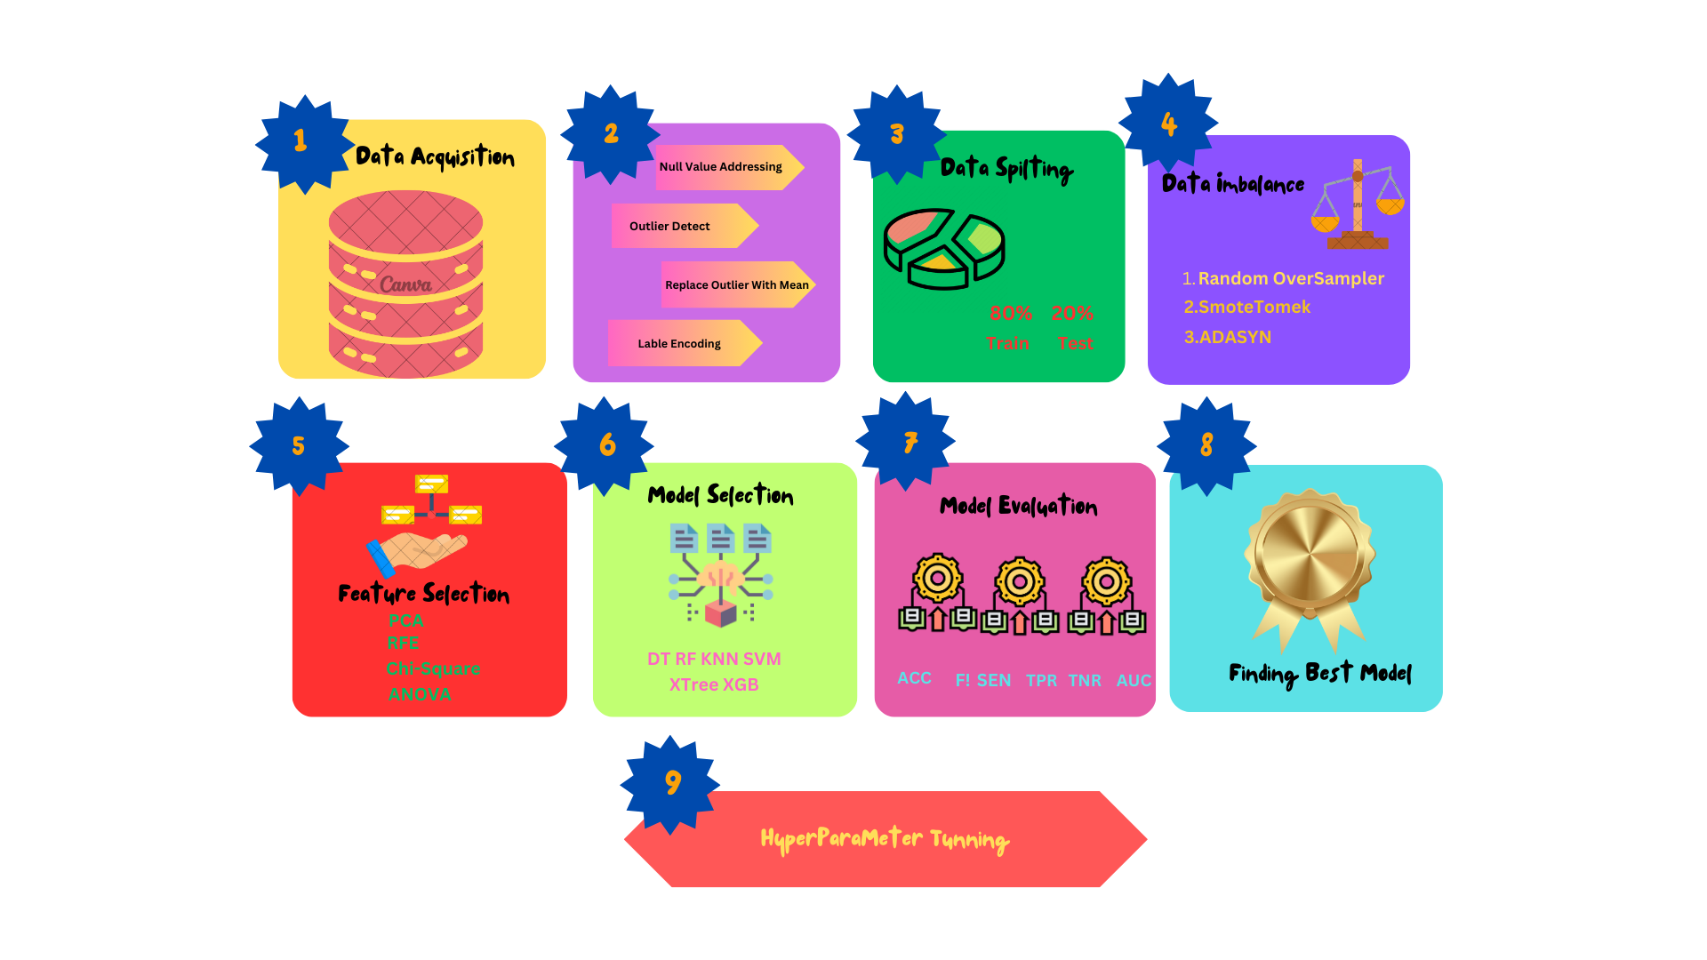

The proposed methodology for analyzing hypertension-related data is structured to systematically ensure accurate and reliable results. The workflow is summarized below:

#### **1. Data Collection**

The dataset utilized in this study was obtained from Kaggle, a popular platform for sharing datasets. The dataset includes various attributes relevant to hypertension, such as demographic details, medical history, lifestyle factors, and hypertension-related measurements. The dataset can be accessed [**here**](https://www.kaggle.com/datasets/khan1803115/hypertension-risk-model-main). This rich collection of data provided a solid foundation for the analysis and machine learning application.

#### **2. Data Preprocessing**

To ensure the dataset's quality, preprocessing steps were applied meticulously:

* **Handling Missing Values:** Missing values were addressed using appropriate imputation techniques to minimize data loss.
* **Outlier Removal:** Outliers were identified using statistical methods and adjusted or removed based on their impact on data distribution. This step ensured that the dataset was clean, consistent, and suitable for machine learning models.  
    
  **After preprocessing the accuracy was:**
* 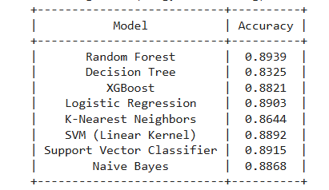

#### **3. Data Balancing**

Medical datasets often suffer from class imbalance, where one class significantly outweighs the other, leading to biased model predictions. To address this, both **SMOTE (Synthetic Minority Oversampling Technique)** and **ADASYN (Adaptive Synthetic Sampling)** were employed:

* **SMOTE** works by creating synthetic samples of the minority class by interpolating between existing samples, ensuring an evenly balanced dataset.

**Accuracy after applying SMOTE was : 0.8903**

* **ADASYN** further extends this by generating synthetic samples adaptively, focusing more on difficult-to-learn examples from the minority class.

**Accuracy after applying ADASYN was: 0.8833**

These techniques not only balanced the target variable, *Risk*, but also improved the models' ability to generalize and reduced bias toward the majority class. This step significantly enhanced the performance and reliability of the machine learning models.

#### **4. Feature Selection**

Key features were identified to enhance model performance and reduce computational complexity. Feature selection was conducted using statistical and machine learning techniques, including:

* **Analysis of Variance (ANOVA)**
* **Chi-Square Test**
* **Principal Component Analysis (PCA)**
* **Recursive Feature Elimination (RFE)** These methods ensured that only the most significant predictors of hypertension were retained for analysis.

The result was like below

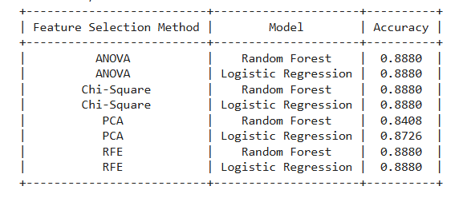

#### **5. Model Application**

The balanced and feature-engineered dataset was used to train and evaluate the following machine learning models:

* **XGBoost**
* **Random Forest**
* **Logistic Regression**
* **Support Vector Machine (SVM)**
* **K-Nearest Neighbors (KNN)** Each model was trained and tested to determine its efficacy in predicting hypertension, with **XGBoost** emerging as the best-performing model.

#### **6. Hyperparameter Tuning**

To optimize the models' performance, hyperparameter tuning was conducted using Grid Search. This process identified the most effective parameter combinations for each model, ensuring peak performance during testing and evaluation.

#### **7. Model Evaluation and Cross-Validation**

The models were evaluated using performance metrics, including:

* **Accuracy**
* **Precision**
* **Recall**
* **F1-Score**

Cross-validation techniques ensured the results were robust, consistent, and free from overfitting. These evaluations provided a comprehensive understanding of the models' performance on unseen data.

#### **8. ROC Curve Analysis**

Receiver Operating Characteristic (ROC) curves were generated for each model to visualize their classification performance. The **Area Under the Curve (AUC)** was calculated to compare the models, with XGBoost demonstrating the highest AUC, highlighting its superior predictive ability.  
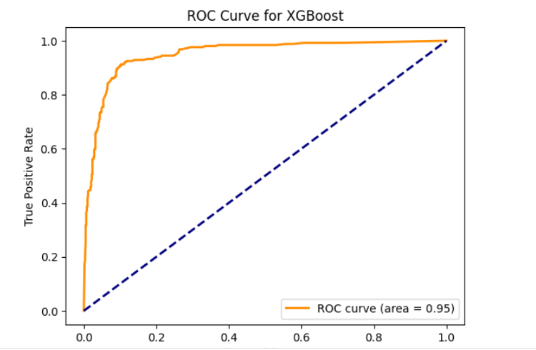

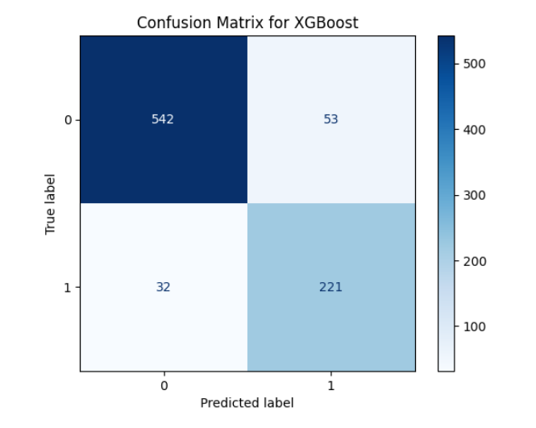

#### **9. Result Analysis**

The final analysis of model performance revealed the following key insights:

* **XGBoost** achieved the highest accuracy, precision, recall, and F1-score, making it the most reliable model for hypertension prediction.
* Critical features like **age, systolic blood pressure (sysBP), diastolic blood pressure (diaBP), BMI, glucose levels, and smoking habits** were identified as significant predictors of hypertension risk.
* The ADASYN technique effectively addressed class imbalance, ensuring reliable and unbiased predictions.

These findings were contextualized and compared with prior research in the domain of hypertension, providing valuable contributions to the field.

#### **10. Termination**

The study concluded with:

* The interpretation of results to draw actionable insights.
* Documentation of key findings, emphasizing the potential of machine learning in hypertension prediction.
* Suggestions for integrating these models into clinical decision-support systems for early intervention.

This structured methodology serves as a roadmap for future research and applications, aiming to improve hypertension management and patient outcomes.

**Perfomance Evaluation Metrics**

Performance evaluation metrics are fundamental to assessing the effectiveness and reliability of machine learning models. These metrics provide insight into how well a model performs in predicting outcomes, enabling a systematic comparison between different algorithms. In this research, we evaluate multiple performance metrics to gauge the efficiency of the models applied to hypertension prediction. Below, we provide a detailed explanation of these metrics, along with their respective mathematical formulas and interpretations.

#### **Accuracy**

Accuracy evaluates the overall correctness of the model by calculating the proportion of correctly predicted instances, both positive and negative, out of the total instances. It is a comprehensive measure that reflects the general performance of the model. The formula for accuracy is as follows:

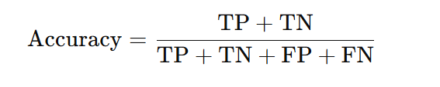

Where:

* **TP**: True Positives (correctly predicted positive cases)
* **TN**: True Negatives (correctly predicted negative cases)
* **FP**: False Positives (incorrectly predicted positive cases)
* **FN**: False Negatives (incorrectly predicted negative cases)

#### **Sensitivity (Recall)**

Sensitivity, also known as recall or the true positive rate, measures the model's ability to correctly identify actual positive cases. It is particularly important in the context of hypertension, where missing true positive cases can have severe consequences. The formula for sensitivity is:

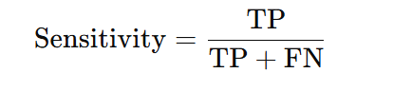

#### 

#### **Specificity**

Specificity quantifies the model's ability to correctly identify negative cases, ensuring that non-hypertension cases are accurately classified. High specificity reduces the likelihood of false alarms. The formula for specificity is:

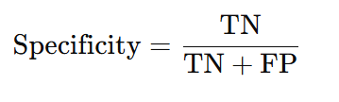

#### **Precision**

Precision is the proportion of correctly predicted positive cases out of all predicted positive cases. It is crucial when the cost of false positives is high, such as in medical diagnoses where unnecessary treatments must be avoided. The formula for precision is:

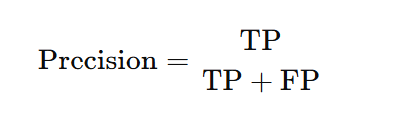

#### **F1-Score**

The F1-Score provides a balanced measure that combines precision and recall. It is particularly useful when the dataset is imbalanced, as it considers both false positives and false negatives. The formula for the F1-Score is:

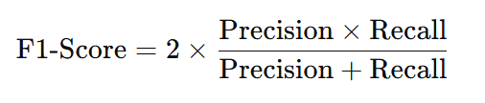

#### **False Positive Rate (FPR)**

The FPR measures the proportion of negative cases that are incorrectly identified as positive. A lower FPR is desirable to minimize false alarms in hypertension detection. The formula is:

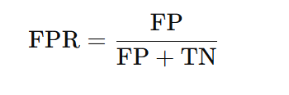

#### **False Negative Rate (FNR)**

The FNR represents the proportion of actual positive cases that are misclassified as negative. Reducing the FNR is critical in hypertension prediction, as missing actual positive cases could lead to untreated conditions. The formula is:

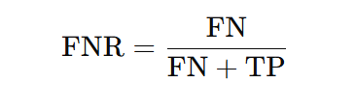

### **Interpretation of Confusion Matrix Components**

To contextualize the metrics, it is essential to define the confusion matrix components:

* **True Positives (TP):** Cases where the model correctly predicts hypertension when the actual condition is hypertension.
* **True Negatives (TN):** Cases where the model correctly predicts no hypertension when the actual condition is no hypertension.
* **False Positives (FP):** Cases where the model incorrectly predicts hypertension when the actual condition is no hypertension.
* **False Negatives (FN):** Cases where the model incorrectly predicts no hypertension when the actual condition is hypertension.

### 

### **Significance in Hypertension Research**

For hypertension prediction, **sensitivity (recall)** is particularly significant, as the primary goal is to ensure that all individuals at risk of hypertension are correctly identified. However, **precision** and **specificity** are equally important to prevent unnecessary anxiety or treatments in individuals without hypertension. The **F1-Score** balances these aspects, providing a holistic view of the model's performance.

By leveraging these evaluation metrics, this research ensures a comprehensive assessment of the machine learning models, ultimately guiding the selection of the most accurate and reliable model for hypertension prediction.

**Result Analysis**

This section presents a detailed analysis of the model performances used to predict hypertension-related outcomes. Various machine learning algorithms were evaluated, and their performances are summarized in terms of **Accuracy**, **Precision**, **Recall**, and **F1-Score**. The evaluation results, as visualized in the accompanying bar chart and performance table, highlight the strengths and weaknesses of each model.

#### **Overview of Models**

The following machine learning algorithms were employed:

1. **XGBoost**
2. **Random Forest**
3. **Logistic Regression**
4. **Support Vector Machine (SVM)**
5. **K-Nearest Neighbors (KNN)**

These models were chosen for their robust capabilities in classification tasks and their proven applicability in medical datasets, particularly for identifying patterns and trends in complex, high-dimensional data.

#### **Performance Metrics**

The analysis relies on the following key evaluation metrics:

* **Accuracy**: The ratio of correctly predicted instances to the total instances.
* **Precision**: The ratio of true positive predictions to the total predicted positives, reflecting how well the model avoids false positives.
* **Recall (Sensitivity)**: The ratio of true positive predictions to the total actual positives, measuring the model's ability to identify all relevant instances.
* **F1-Score**: The harmonic mean of precision and recall, balancing the trade-offs between these two metrics.

#### **Key Findings**

1. **XGBoost**
   * **Highest Performer**: XGBoost achieved the best performance across all metrics, with an **accuracy of 89.98%**, **precision of 90.31%**, **recall of 89.98%**, and **F1-Score of 90.08%**.
   * **Interpretation**: This result indicates that XGBoost excels in both precision and recall, making it the most reliable model for predicting hypertension risk in this context.
   * **Strengths**: XGBoost's ability to handle missing data and its feature importance ranking mechanism contribute to its high performance.
2. **Random Forest**
   * **Accuracy**: 89.85%, marginally lower than XGBoost.
   * **Precision**: 90.11%; slightly better than XGBoost, indicating fewer false positives.
   * **Recall**: 89.89%, on par with XGBoost.
   * **F1-Score**: 89.99%.
   * **Interpretation**: Random Forest demonstrates strong overall performance, particularly in precision, making it a close competitor to XGBoost.
3. **Logistic Regression**
   * **Accuracy**: 89.03%, slightly lower than ensemble-based models.
   * **Precision**: 88.87%, **Recall**: 89.03%, and **F1-Score**: 88.60%.
   * **Interpretation**: Logistic Regression is effective but lags behind ensemble methods. It performs well in simpler, linearly separable scenarios, but its limitations in handling complex, nonlinear patterns may explain the lower scores.
4. **Support Vector Machine (SVM)**
   * **Accuracy**: 88.91%.
   * **Precision**: 88.75%, **Recall**: 88.91%, and **F1-Score**: 88.78%.
   * **Interpretation**: While SVM is a robust classifier, its performance falls short of ensemble models, likely due to its computational intensity and sensitivity to parameter tuning.
5. **K-Nearest Neighbors (KNN)**
   * **Accuracy**: 87.73%, the lowest among the models evaluated.
   * **Precision**: 87.53%, **Recall**: 87.73%, and **F1-Score**: 87.55%.
   * **Interpretation**: KNN's performance suggests its reliance on the quality of data and distance metric. It is less effective in high-dimensional datasets with potential noise.

#### **Visual Analysis**

The bar chart provides a visual comparison of the models' performances across all metrics. The near-parallel height of the bars for XGBoost and Random Forest indicates their superior and consistent performance across all evaluation parameters. On the other hand, the comparatively lower bars for KNN highlight its limitations in this dataset.

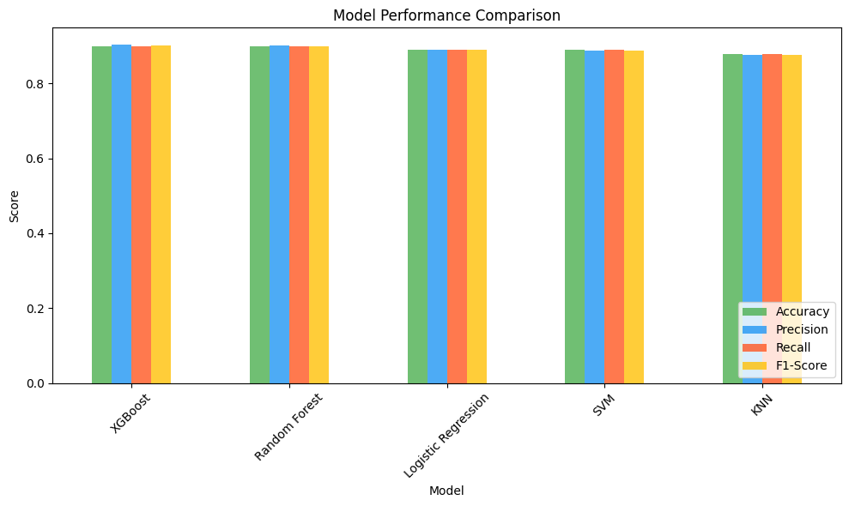

**Conclusion**

Hypertension, often referred to as a "silent killer," poses a significant global health burden due to its asymptomatic nature and potential to lead to severe cardiovascular diseases. Early detection and accurate prediction are critical in mitigating the associated risks and ensuring timely intervention. This research contributes to the field of hypertension prediction by applying advanced machine learning techniques to analyze key health metrics and develop robust predictive models.

Through a comprehensive evaluation of models, including **XGBoost, Random Forest, Logistic Regression, SVM, and KNN**, the study highlights the ability of machine learning to extract meaningful insights from complex health data. Among the evaluated models, **XGBoost** emerged as the most effective algorithm, achieving the highest performance metrics across accuracy, precision, recall, and F1-score. This superior performance underscores XGBoost’s capacity to handle large datasets, manage imbalanced data distributions, and capture non-linear relationships between features.

The analysis demonstrates the importance of key features such as **age, systolic and diastolic blood pressure, BMI, glucose levels, and smoking habits** in predicting hypertension risk. By identifying these critical predictors, this research offers valuable insights into risk factor prioritization, aiding clinicians and policymakers in resource allocation and preventive strategies.

In addition to providing a clear framework for model evaluation, the study emphasizes the role of **sensitivity and specificity** in balancing false positives and false negatives. Given the high stakes in medical predictions, where false negatives could leave cases untreated and false positives could lead to unnecessary treatments, this balance is paramount. The integration of oversampling techniques like ADASYN ensures the robustness of the models, addressing class imbalance and enhancing the reliability of predictions.

This research also highlights the significance of leveraging interpretability in machine learning models for healthcare applications. While high-performing models like XGBoost deliver superior predictive accuracy, ensuring their outputs are understandable to healthcare professionals is essential for practical implementation. Future work should focus on enhancing model interpretability using techniques such as SHAP (SHapley Additive exPlanations) or LIME (Local Interpretable Model-agnostic Explanations).

In conclusion, this study demonstrates the potential of machine learning as a transformative tool in the domain of hypertension management. By combining advanced algorithms with domain knowledge, this research lays the foundation for developing intelligent, data-driven decision-support systems. These systems can empower healthcare providers to make informed decisions, improve patient outcomes, and ultimately reduce the societal burden of hypertension. Future studies could expand on this work by incorporating longitudinal datasets, exploring real-time monitoring systems, and integrating genetic and lifestyle data to further enhance prediction capabilities.

This research signifies a step forward in the integration of technology with healthcare, providing a pathway toward more personalized, efficient, and accurate hypertension management. The findings reaffirm the importance of adopting machine learning in the broader context of preventive medicine, emphasizing its potential to revolutionize the detection and treatment of chronic diseases.

**References**

[1]S. Dogan, P. D. Barua, Turker Tuncer, and U. R. Acharya, “An accurate hypertension detection model based on a new odd-even pattern using ballistocardiograph signals,” Engineering Applications of Artificial Intelligence, vol. 133, pp. 108306–108306, Mar. 2024, doi: https://doi.org/10.1016/j.engappai.2024.108306.

‌

[2]S. Abbas, G. A. Sampedro, Moez Krichen, M. A. Alamro, Alaeddine Mihoub, and R. Kulhanek, “Effective Hypertension Detection Using Predictive Feature Engineering and Deep Learning,” IEEE Access, vol. 12, pp. 89055–89068, Jan. 2024, doi: https://doi.org/10.1109/access.2024.3418553.

‌

[3]E.-S. A. El-Dahshan, M. M. Bassiouni, S. K. Khare, R.-S. Tan, and U. R. Acharya, “ExHyptNet: An explainable diagnosis of hypertension using EfficientNet with PPG signals,” Expert Systems with Applications, vol. 239, pp. 122388–122388, Nov. 2023, doi: https://doi.org/10.1016/j.eswa.2023.122388.

‌

[4]C. J. L. Murray et al., “Global Burden of 87 Risk Factors in 204 Countries and territories, 1990–2019: a Systematic Analysis for the Global Burden of Disease Study 2019,” The Lancet, vol. 396, no. 10258, pp. 1223–1249, Oct. 2020, doi: https://doi.org/10.1016/s0140-6736(20)30752-2.

‌

[5]A. Gudigar et al., “Directional-Guided Motion Sensitive Descriptor for Automated Detection of Hypertension Using Ultrasound Images,” IEEE Access, vol. 12, pp. 3659–3671, 2024, doi: https://doi.org/10.1109/ACCESS.2023.3349090.

‌

[6]S. Oparil et al., “Hypertension,” Nature Reviews Disease Primers, vol. 4, no. 4, pp. 1–48, Mar. 2019, doi: https://doi.org/10.1038/nrdp.2018.14.

‌

[7]S. Lundberg and S.-I. Lee, “A Unified Approach to Interpreting Model Predictions,” arXiv.org, Nov. 24, 2017. https://arxiv.org/abs/1705.07874v2

‌

[8]A. Mocumbi et al., “Publisher Correction: Pulmonary hypertension,” Nature Reviews Disease Primers, vol. 10, no. 1, Jan. 2024, doi: https://doi.org/10.1038/s41572-024-00493-2.

‌

[9]T. J. Guzik, Ryszard Nosalski, P. Maffia, and G. R. Drummond, “Immune and inflammatory mechanisms in hypertension,” Nature Reviews Cardiology, Jan. 2024, doi: https://doi.org/10.1038/s41569-023-00964-1.

‌

[10]J. Fang, C. Gillespie, C. Ayala, and F. Loustalot, “Prevalence of Self-Reported Hypertension and Antihypertensive Medication Use Among Adults Aged ≥18 Years — United States, 2011–2015,” MMWR. Morbidity and Mortality Weekly Report, vol. 67, no. 7, pp. 219–224, Feb. 2018, doi: https://doi.org/10.15585/mmwr.mm6707a4.

‌

[11]O. Pak et al., “Impact of the mitochondria-targeted antioxidant MitoQ on hypoxia-induced pulmonary hypertension,” European Respiratory Journal, vol. 51, no. 3, p. 1701024, Feb. 2018, doi: https://doi.org/10.1183/13993003.01024-2017.

‌

[12]J. Huang, “Effect of Health Management in Raising Awareness Rate of Disease Prevention and Treatment in Patients with Prehypertension,” Journal of Biosciences and Medicines, vol. 12, no. 02, pp. 236–243, Jan. 2024, doi: https://doi.org/10.4236/jbm.2024.122018.

‌

[13]F. Sahatqija et al., “Awareness of Hypertension, Hypercholesterolemia, and Diabetes Mellitus and Associated Characteristics in Russian Adults,” International Journal of Hypertension, vol. 2024, p. 8542671, 2024, doi: https://doi.org/10.1155/2024/8542671.

‌

[14]R. D. Pinto et al., “CARDIOMETABOLIC RISK FACTORS AND LIFESTYLE HABITS IN THE GENERAL POPULATION: RESULTS OF AN AWARENESS-RAISING EDUCATIONAL CAMPAIGN FOR HEALTH EMPOWERMENT,” Journal of Hypertension, vol. 42, no. Suppl 1, pp. e167–e167, May 2024, doi: https://doi.org/10.1097/01.hjh.0001021060.61915.f3.

‌

[15]F. J. Charchar et al., “Lifestyle management of hypertension: International Society of Hypertension position paper endorsed by the World Hypertension League and European Society of Hypertension,” Journal of Hypertension, vol. 42, no. 1, pp. 23–49, Sep. 2023, doi: https://doi.org/10.1097/HJH.0000000000003563.

‌

[16]T. D. Backer et al., “PREVALENCE, AWARENESS AND THERAPEUTIC CONTROL OF HYPERTENSION IN BELGIUM: AN OPPORTUNISTIC SCREENING OF NEARLY 6,000 PARTICIPANTS DURING THE MAY MEASUREMENT MONTH CAMPAIGNS 2017-23,” Journal of Hypertension, vol. 42, no. Suppl 1, pp. e167–e167, May 2024, doi: https://doi.org/10.1097/01.hjh.0001021064.87523.f5.

‌

[17]A. A. Leung, J. V. A. Williams, R. S. Padwal, and F. A. McAlister, “Prevalence, Patient Awareness, Treatment, and Control of Hypertension in Canadian Adults With Common Comorbidities,” CJC Open, vol. 6, no. 9, pp. 1099–1107, May 2024, doi: https://doi.org/10.1016/j.cjco.2024.05.012.

‌

[18]Mohammad Jahid Hasan et al., “Health-care-seeking behaviour in patients with hypertension: experience from a dedicated hypertension centre in Bangladesh,” Blood pressure, vol. 33, no. 1, May 2024, doi: https://doi.org/10.1080/08037051.2024.2339434.

‌

[19]A. J. JAMES, F. Folarin, and G. O. ONIPEDE, “TACKLING RISING CASES OF STROKE AND HYPERTENSION AMONG YOUNG ADULTS THROUGH STRATEGIC COMMUNICATION IN NIGERIA,” vol. 4, no. 2, pp. 193–204, May 2024, doi: https://doi.org/10.57233/gujos.v4i2.15.

‌

[20]A. A. Jones, J. K. Lippincott, M. P. Gonzalez, and J. E. Kim, “Pregnancy-induced hypertension,” Elsevier eBooks, pp. 437–448, Jan. 2024, doi: https://doi.org/10.1016/b978-0-443-15583-3.00033-0.

‌